**Project 4 Part 1 (k-means for 100 2d points)**

Name: Anup Bagali Period: 7

Date: 11/06/2021

Is your lab name l041?(lowercase L followed by digits 041) yes

Did you created a class to store a point? yes

Does your main contain only a call of method part1()? yes

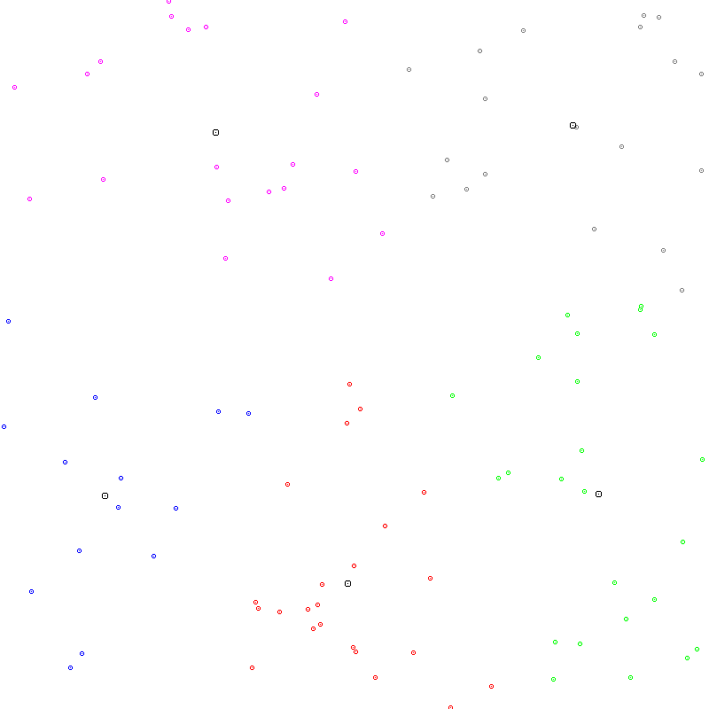Paste here 2 clear pictures of the clusters.ppm you created in 2 different runs:

